**Source Control**

For source control, Group 111 had chosen github to maintain files and folders publically so all were able to easily download, edit and re-upload files. All document files were originally uploaded periodically over the course of the development of the solution, however due to a technical error, all files were wiped from the repository and had to be re-added.

The ‘website ‘and ‘source-code’ folders contain the latest versions of the website/app implementation, ‘source-code’ containing the source code for the working implementation with full database and PHP integration and ‘website’ which contains the basic HTML versions. These were not committed originally on a regular basis as our scrum plan outlines that our group planned to integrate our application solution using a continual integration method through a remotely hosted domain, and as these elements were being developed by one team member each, the idea of posting it to the repository before it was ready appeared redundant.

Weekly progress of implementation, Release 1:

* Week 5
  + Begun basic HTML
  + Created base login page
* Week 6
  + Began integrating Cascading style sheets
  + Implemented welcome page
  + Basic layout implemented
* Week 7
  + Introduction of first form
  + Re-evaluated design, changed to use a top oriented, horizontal navigation bar
  + Adjusted login screen
  + Created ‘Anchor’ logo
  + Further improvements to CSS document including animations on form fields
* Week 8
  + Adjusted container size from 960px to 90% screen width to better suit adjustability
  + Navigation layout changed to block style selections to account for portable device usage
  + Colour scheme set
* Week 9
  + Database created and linked
  + Website hosted onto x10hosting
  + Website modified from basic HTML to use php
  + Website interacts with database, stores data. Retrieving and displaying data from the database is planned for Release 2.

*Github*

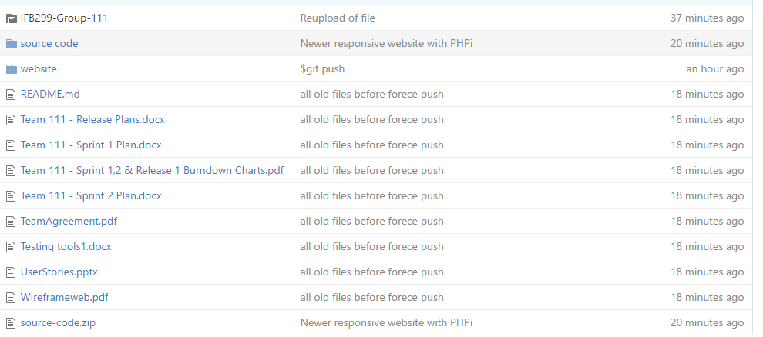

*“Source-code” subfolder*

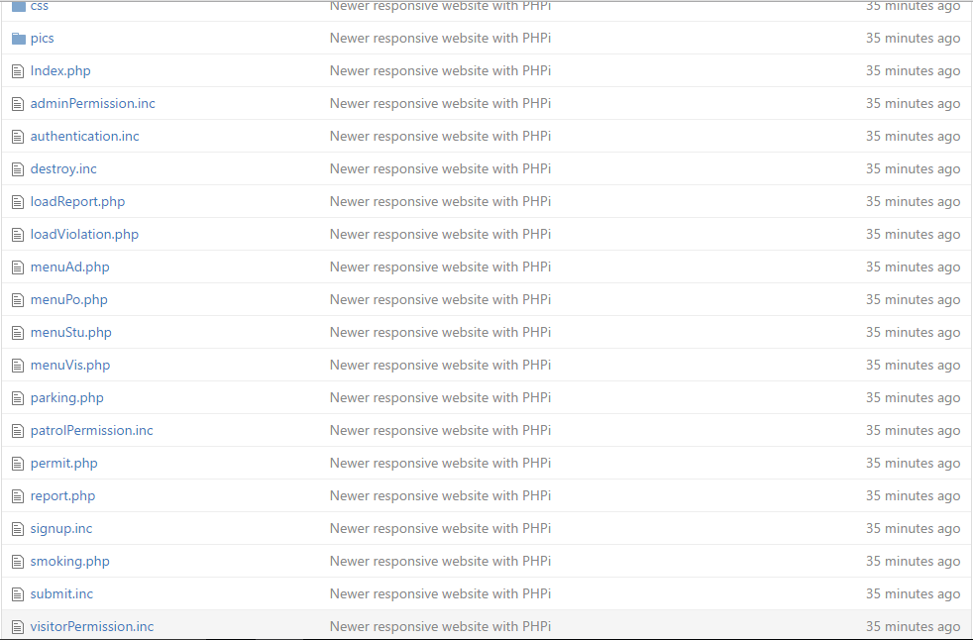

*“Website” subfolder*

